- 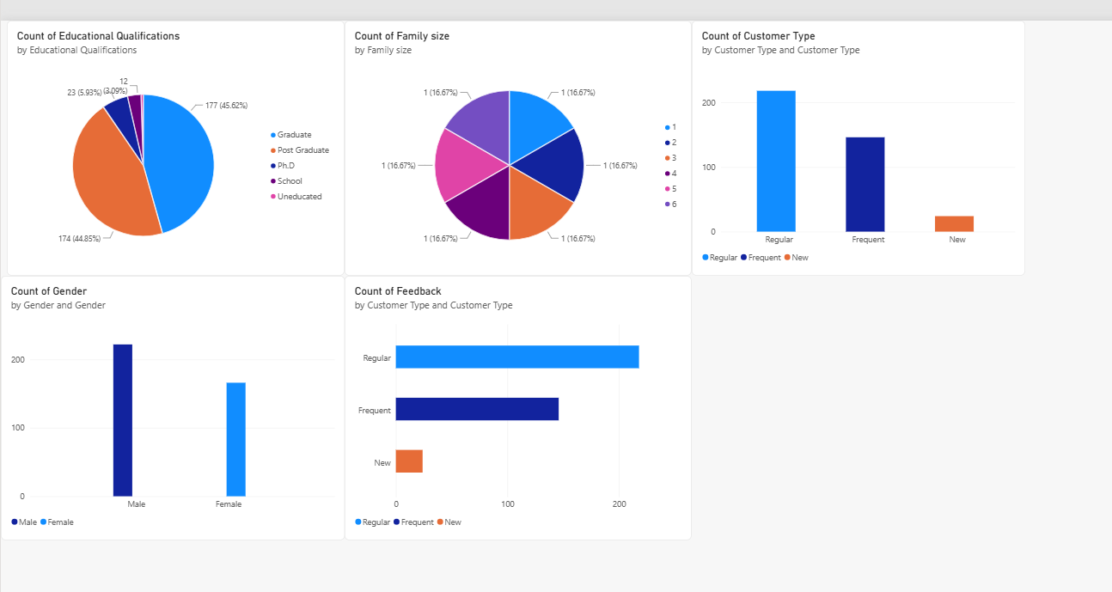Education: customers are almost entirely Graduate (45.6%) or Post Graduate (44.9%), together about 91% of the dataset. PhD, School, and Uneducated combined make up under 10%. Highly education-skewed customer base.
- Family size pie: all six slices show exactly 16.67% each, which is a red flag, not a real pattern. It means the pie is counting the field values 1 through 6 themselves rather than counting customers per family size. The real breakdown from the data is size 3 households most common at 117, then size 2 at 101, then size 4 at 63. Very different from an even split. This chart needs the measure fixed to count something like Age grouped by Family size, not count of Family size itself.
- Customer Type: Regular is the largest group at 218, followed by Frequent at 146, and New customers are a small minority at 24. Consistent across both charts.
- Feedback chart mislabeled: the bottom chart titled Count of Feedback by Customer Type is actually just showing Count of Customer Type again, Regular, Frequent, New, not Positive or Negative feedback. The real feedback split is heavily positive, 317 Positive versus 71 Negative overall, about 82 percent positive, and that holds proportionally across all three customer types. No group stands out as unusually dissatisfied.
- Gender: Male customers at 222 outnumber Female at 166, roughly 57 to 43 percent.
- Two things to fix: the Family size pie chart measure, and the mislabeled Feedback bar chart which is currently duplicating the Customer Type chart instead of showing actual feedback data.

